1. **Python Program to Find the Largest Number in a List without using sorting algorithm**

l=[]

n=int(input("enter n value"))

print("enter list element")

for i in range(0,n):

  e=int(input())

  l.append(e)

print("original list: ",l)

a=max(l)

print("Largest element in list :" , a)

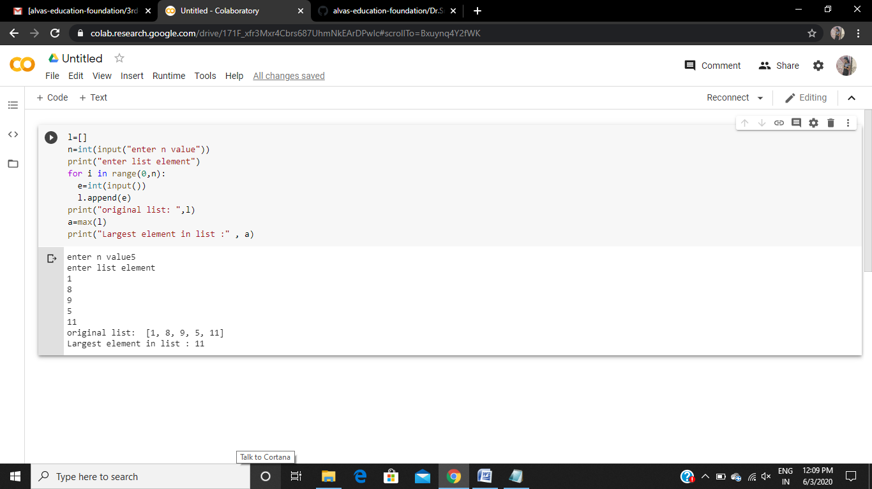

1. **Python Program to Find the different digits r from numbers n using permutstions**

from itertools import permutations

perm=[]

n=int(input("enter n value"))

print("enter list element")

for i in range(0,n):

  e=int(input())

  perm.append(e)

print("original list: ",l)

r=int(input("enter r value"))

perm = permutations(perm, r)

for i in list(perm):

    print(i)

OUTPUT:

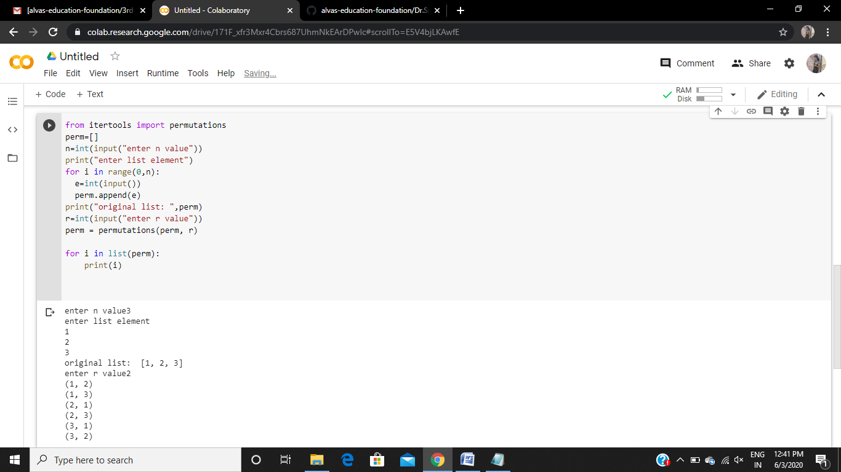

1. **Python Program to find different digits r from number n using combination**

from itertools import combinations

c=[]

n=int(input("enter n value"))

print("enter list element")

for i in range(0,n):

   e=int(input())

   c.append(e)

print("original list: ",c)

r=int(input("enter r value"))

c = combinations(c, r)

for i in list(c):

   print(i)

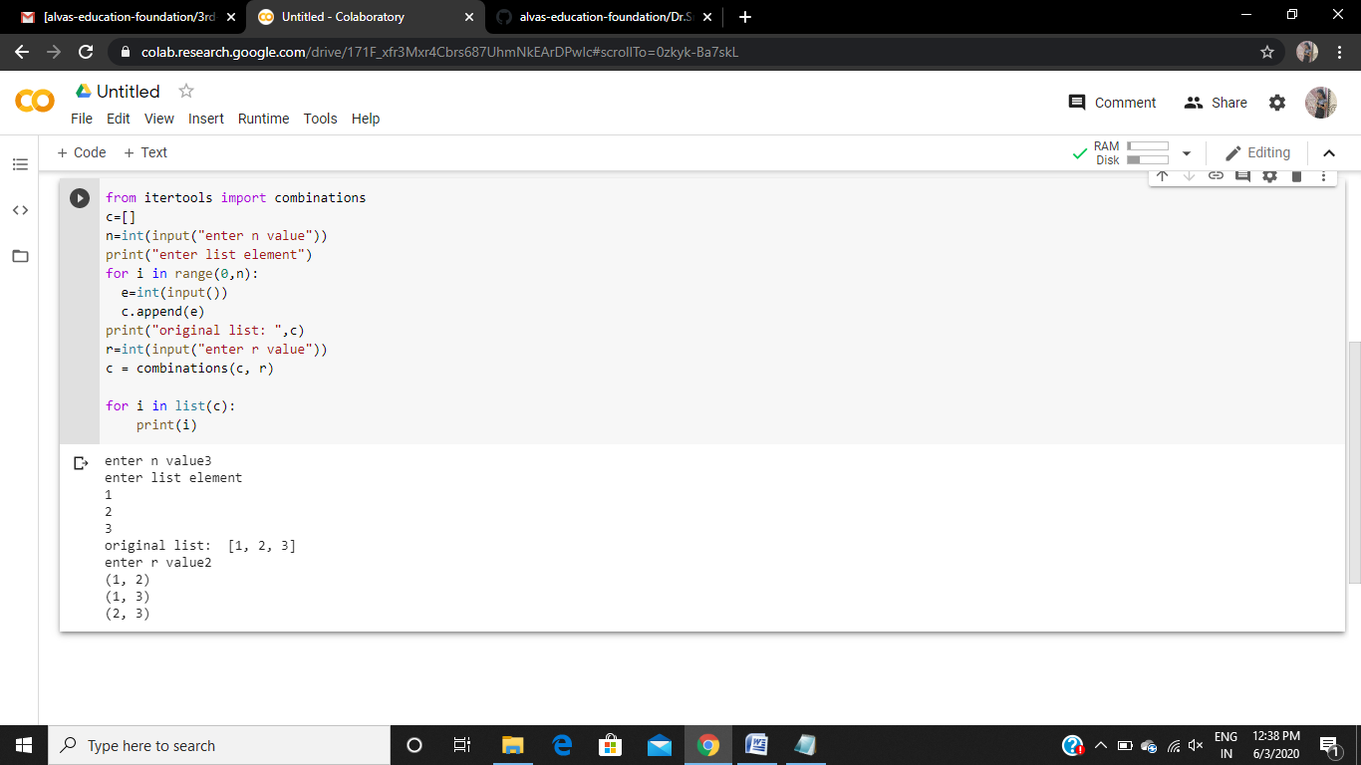

1. **Python Program to Map Two Lists into a Dictionary**

n=int(input("enter n value"))

k=[]

v=[]

print("enter values")

for i in range(0,n):

  e=(input())

  v.append(e)

print("enter keys")

for i in range(0,n):

  e=(input())

  k.append(e)

m=dict(zip(k,v))

print(m)

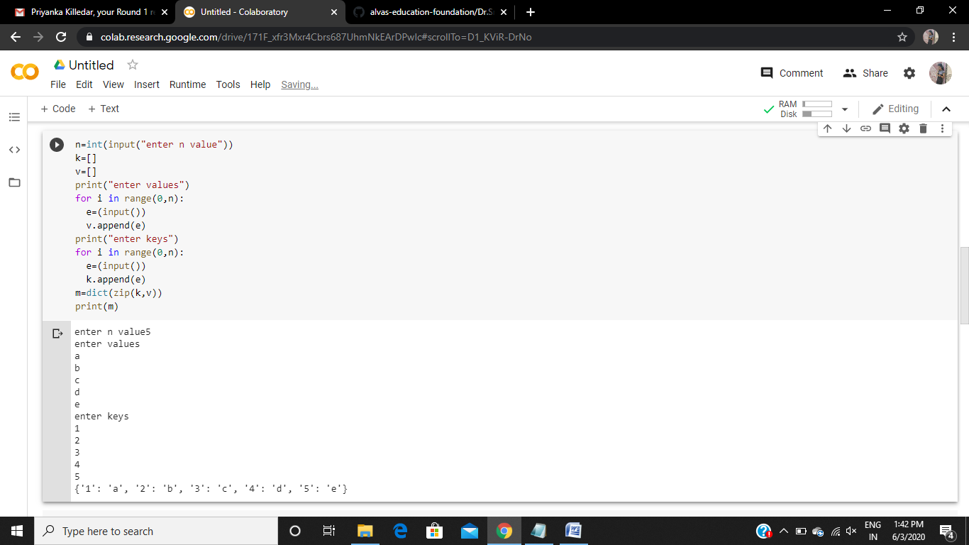

1. **Python Program to Accept a Hyphen Separated Sequence of Words as Input and Print the Words in a Hyphen-Separated Sequence after Sorting them Alphabetically**

n = input("Enter The Hyphen Separated Sequence Of Words: ")

a = n.split('-')

a.sort()

print('-'.join(a))

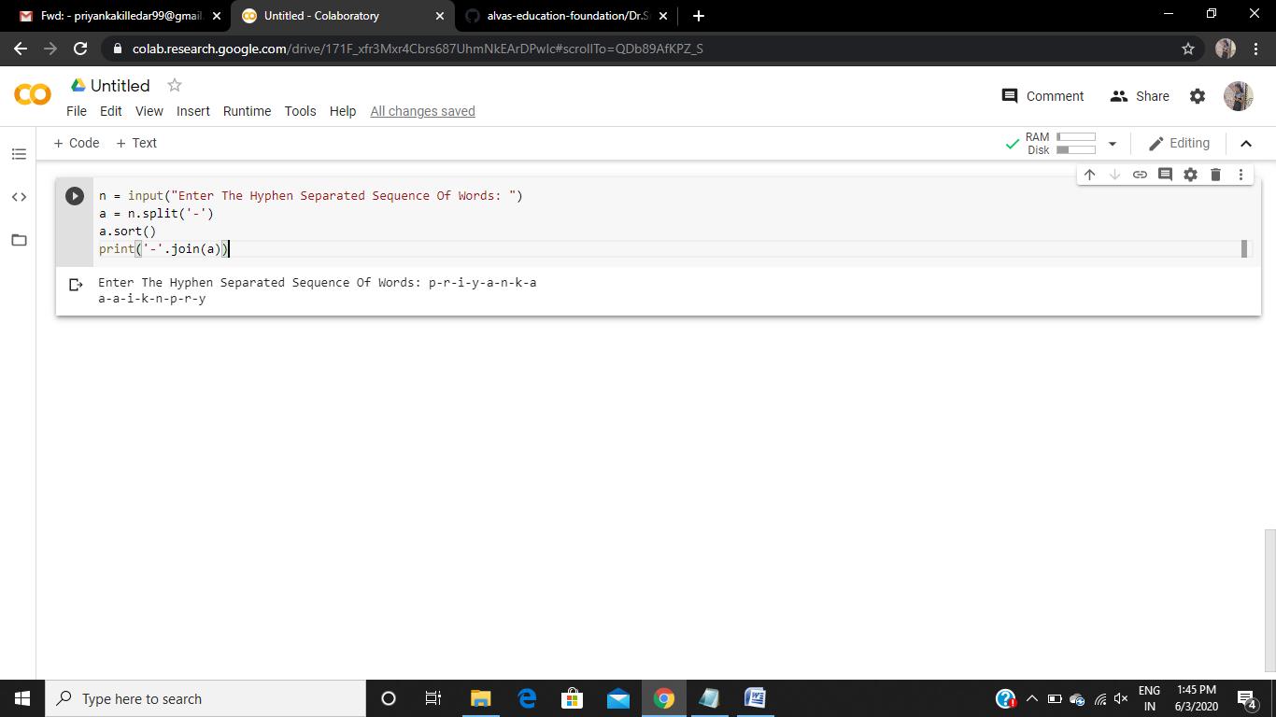

1. **Python Program to Take in the Marks of 5 Subjects and Display the Grade using if ... elif construct without using and operator for finding the range**

n = int(input("Enter The Number Of Subjects: "))

a = []

for i in range(n):

    print("Enter The Marks Of Sub-", i+1)

    a.append(int(input()))

s = 0

for i in a:

    s = s + i

avg = s/n

if(avg >= 90):

    print("Grade: A")

elif(avg >= 80):

    print("Grade: B")

elif(avg >= 70):

    print("Grade: C")

elif(avg >= 60):

    print("Grade: D")

else:

    print("Grade: F")

